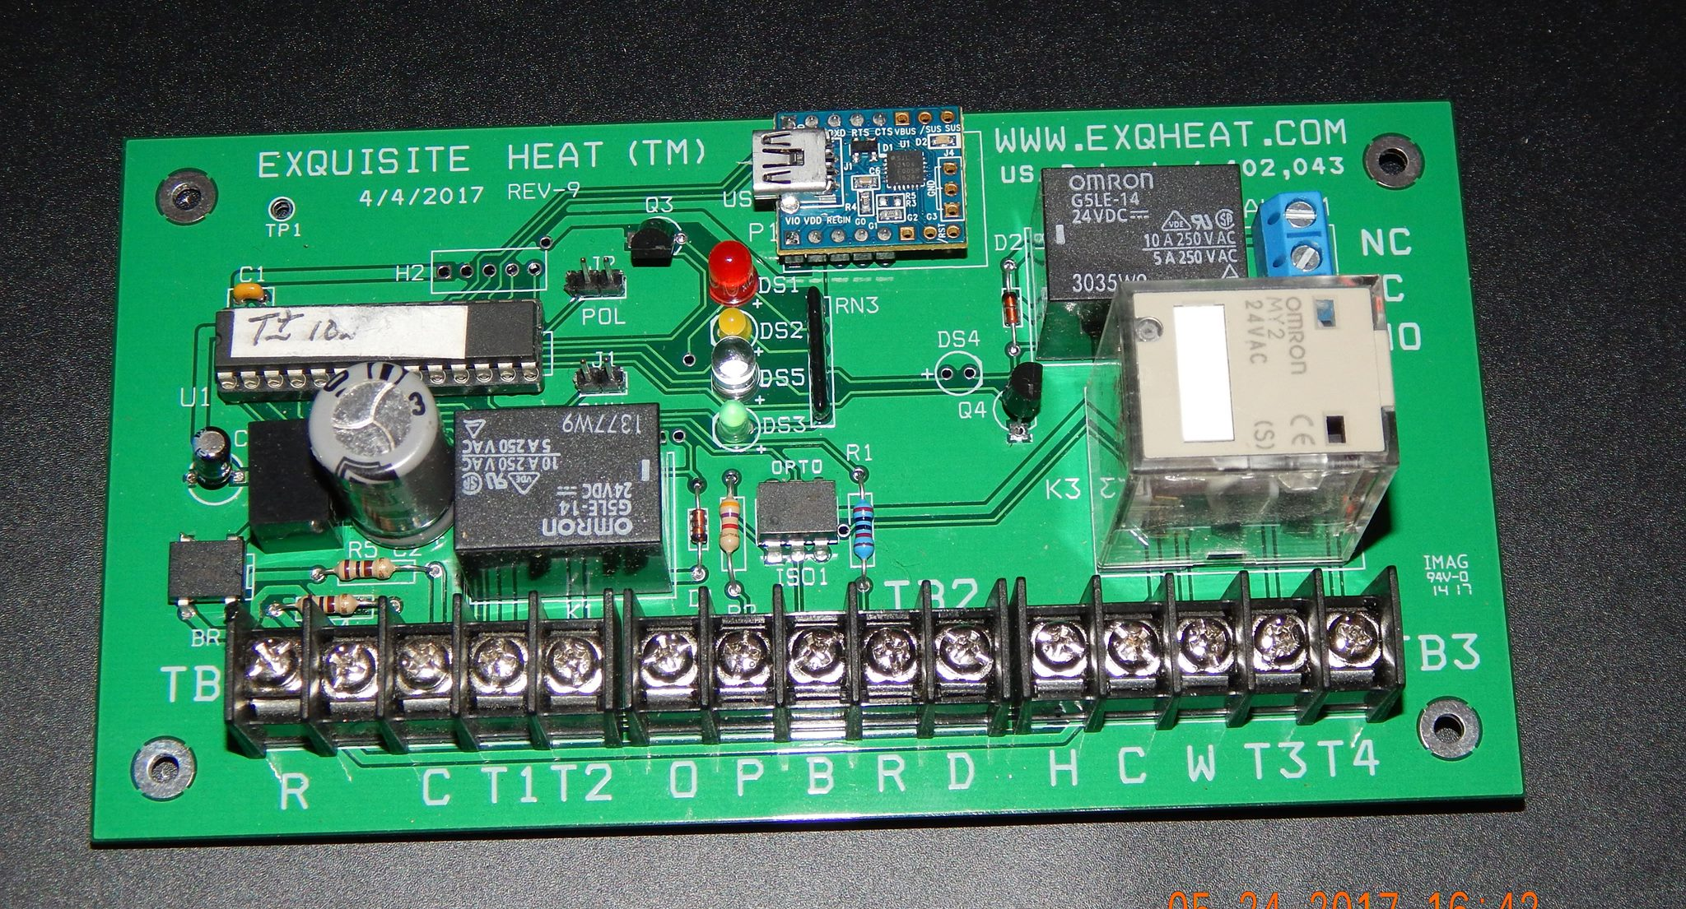
Welcome to Exquisite Heat Rev 9 & MZ9-Rev-C for Steam Boilers
Before installation turn off the boiler power source at the main power circuit panel, or boiler safety switch, if Main Panel is not available. You should mark the Main Panel boiler breaker with a marker for future service visits. Use your multimeter to assure there is no 120Vt source at the boiler. If improperly wired at the panel, there will be voltage somewhere near the boiler. Be warned. It can happen. Properly wired panels should disconnect the load voltage to the boiler.
Supplies:
24vac va 40 transformer
Honeywell TH811R with Red Link
Honeywell Home Model 48A2E6C66CE5 Rec Link Interface
Honeywell C7189R Wireless Indoor Sensor
Honeywell Wired Sensor
24 volt coil relay for high voltage connections. (Allen Bradley, Cutler Hammer, RIB)
Manual by pass switch for manual reset/bypass
2 wire thermostat brown wire 18 gauge.
4 wire brown thermostat cable needed for sensor runs in apartments. Extra wires are needed in case of a wire failure. In side apartment exposed wire can be 2 wire white 22 gauge.
Brown thermostat 2 wire for transformer wire runs, inside, boiler sensor runs, boiler TT runs,
4 wire brown for thermostat run 18 gauge.
8 wire Brown, 18 gauge for main wire run from Exqheat to boiler area. This wire can be used for all wires needed at the boiler. You may not use all the wires, but the extras may be useful as you proceed with your installation and maintenance. Twist pair at both ends> Bl-Wh, R-G, Or-Br, Blk-Yel. This will avoid mistakes in connections
Wire stripper, wire ties ( do not wrap to hot steam piping) electrical test meter, staple gun, wire ( small and large) , screw drivers, head lamp, electrical gloves, dry floor mat, eye protection, and electric drill with hammer feature ( for concrete anchor mounting of control box) installation and make sensor wire runs, ladder for overhead wire runs.
A helper employee can be used to help with long wire sensor location, basic install wiring, ladder safety, run for tools and parts. A labor saving tip: locate a non used telephone cable to sensor apartment.
Burner Connection
A jumper ( white wire ) should be attached between T2 and T3. This allows the main thermostat relay at T4 to operate in series with controller relay a
T1. Should the controller software fail the T1, T2 relay will close, so the thermostat relay can operate the boiler, until Exqheat controller service can be arranged.
Boiler Supply temperature
B & R In steam applications this sensor attached between B&R, is used as an additional safety shut off if attached to the lower 1/2 of the boiler Hartford loop senses high temperature.( above 200F) High temperatures would be created by steam in the Hartford loop as water levels lower in the boiler. The boiler would be shut down for service to examine the reason for loss of water. To restart the Exqheat it can be reset by disconnecting a power wire to the Exqheat controller momentarily, and reconnecting the power. The Exqheat should go into start up mode.
O & P Not used for steam applications.
THERMOSTAT: I prefer the Honeywell 8000 with Red Link series with remote sensor. (RF wireless available) You can use up to two sensors for averaging if needed. Look at it carefully. One sensor properly located will do the trick. There is, after all, just one boiler.
Remote temperature sensor is required where the occupants cannot be relied upon to use reasonable manual thermostat settings. A dry thermostat that works on a dry closure to trigger the 24 volts from the boiler ( Honeywell T 87 ) can be charged with a voltage by attaching the thermostat wires to C(R) & W connections in front of the main relay ( large relay on the right side of the terminal block on the Exqheat board ).
Where thermostat security location is not an issue any thermostat (dry circuit or powered programmable) can be used. Managing the wiring will require the polarity considerations discussed above. All system requirements for thermostat wiring can be achieved at the C(R) W terminals on the large main relay at the right of the board. If you have a dry thermostat ( 24 volt ) power is available at these board C(R) & W terminals. For powered thermostat attach W on the thermostat direct to W on the Exqheat board. The ground will be common between the board and thermostat. 4 wire thermostat cable attaches from thermostat using Red wire from Rc to R, White wire from C to C, green wire from W to W, blue wire from R to C(R) on large relay. Be sure to remove the jumper from the Rc-R on the thermostat.
Remote thermostat Sensor location: not near the kitchen or windows that may be opened. The hall between bedrooms outside a closet makes a suitable sensor location. Read sensor instructions for location and wiring. Remind folks not to paint the sensor, or tell anyone they know what the sensor is. They will be a popular neighbor in the middle of the night. You want to locate the sensor on the top two floors of the building, with a cooperative family. The landlord may be of help on this one. Abandoned telephone wires to the apartment may help ease of wiring.
Burner Connection
Take another two wire cable and run it from the burner T T up to the (blue and white) wire to Exqheat 8 wire cable to T1 and T4 at the control.
Some boilers do not have a 24 volt low voltage TT. Riello is one. Some boilers will require a low to high voltage relay (Honeywell R845A) in series to bridge the gap from Exqheat TT to the high voltage burner operating voltage. Be sure to check all circuits with your multi meter to assure you understand the needs for adaptation. Always check the TT voltage at the boiler before making connections. Be sure to check all circuits with your multimeter.
TT voltage at boiler should be 24-110vac. Test run your boiler with thermostat at TT. Higher voltages will require a supporting high voltage relay with a 24 VAC coil to 240 volt relay capacity ( Cutler-Hammer, Allen-Bradley, RIB 24 volt coil, or equivalent).
Wire 24 Volt coil circuit from transformer R through relay 24 va coil to T1, then from T4 back to transformer C on the left end of the control. Attach Blue and white wire from boiler to the normally open High Voltage (dry) poles of the new relay.
Low water safety This temperature sensor (10K supplied) is connected to B-R and placed against the Hartford Loop on the boiler return one half way down the warm pipe between the closed nipple and the base of the boiler. This sensor will detect high temperature as the sensor is exposed to steam in the lower half of the return, as water level lowers from lack of make-up water replacement. Use Brown and Orange wires to controller. If low water condition occurs, the Exqheat will shut down the heating system by opening T1 T2. After water level repair, the Exqheat can return heating by resetting the control. Disconnect and reconnect power R to the control to reset control.
Domestic Hot Water
D & H serve as connections for domestic hot water temperature 10k sensor ( black and yellow wire in 8 cable) attached to the domestic hot water pipe leaving the boiler tankless coil, if there are not other methods of controlling domestic hot water temperatures. There may be a separate aqua-stat to control DHW boiler temperatures, mixing valves, or separate storage with its own aqua-stat. If the DHW temps are already being controlled, there will be no need for the sensor from Exqheat. In this case the supplied 10k resistor would be left in place between D-H. Remember the temperature at the faucets should not be above 110 F to assure avoiding the risk of scalding temperature at the end user.

Alarm Relay: This alarm will activate if High or Low temperature limits set in software are reached. This can be arranged for a local powered bell circuit, an alarm system communicator, or independent telephone dialer. Rest after service is accomplished by a temporary disconnect of control power at terminal R.

By Pass Switch This is provided in order to disconnect the Exqheat control from the heating system. The switch is placed on T1 T2. When down, switch will close connecting T1 and T2 closing the cut off circuit, leaving the thermostat in control. This way diagnosis of a control or boiler problem can be isolated while on the telephone. Mount the switch on side, front or top of the control cabinet. The UP position for the switch will be the open circuit position. In the down position the T1 T2 relay is manually closed. The switch should be in the up position ( or to the left when placed on top of box) for normal control operation. If there is a heat failure, have the operator turn the switch to the down position. ( or to the right) Be sure there is water in the boiler water level glass. If the heat is not returned, call boiler service. If switch in the down position, and the boiler starts right away, you will need to call for Exqheat service. The boiler will run from thermostat in the mean time while in the down position. This eliminates emergency service for Exqheat control. Be sure switch is adjusted “Control ON” (UP) after services are completed to return Exqheat control to service.
Thermostat Wiring : red Rc , white C, blue R, green W to control : red R, white C, blue C(R), green W.
Power Connections
It is necessary to check out the polarity of the 24volt power supply. You are looking for the Load terminal. Attach the red wire for power supply from the load side of the 24volt VA transformer to Exqheat control system R terminal. A separate R red wire will also be connected to the thermostat Rc input. The white wire will be the C terminals on the transformer, to Exqheat controller and the thermostat. Now the controller and the thermostat are in polarity synchronization and will assure smooth circuitry. This wiring can be made at the convenience of the installer.
R (load) power at the transformer should not be connected until all other connections are made and carefully checked and rechecked.

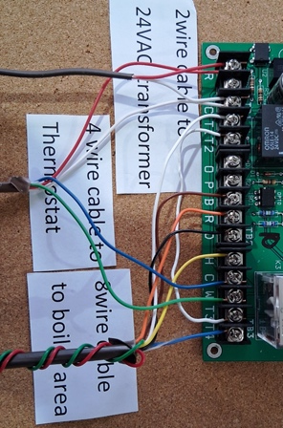

Power up
Check all connections, color of wires, and connection security (tighten screws)
The thermostat should come to life.
R red, C white, T1 to T3 white jumper , D-H black and yellow or 20K resister (supplied), W- C(R) green and blue wires from thermostat R and W dry closure. Be sure thermostat jumper between Rc and R is removed.
Finally connect the red wire to the transformer load connection.
Lights
The controller Green light will flash frequently for one minute surge delay time. The green light will flash at a slower rate once delay is finished. This light indicates proper operation of software. If it is out the control has failed. Close bypass switch (down)
The Yellow light will indicate a call for heat at the thermostat. If this light is not on when there is a call for heat, check polarity of wiring. (Reverse control power wires at the control power connections at R-C on the left. Leave thermostat power wires in position) Polarity can also be adjusted at Jumper 2 pin on the board.
The RED light indicates closure at the T1 T2 when the light is OFF. The red light will light up when the boiler cut off relay turns the boiler off at T1 T2. When the light is off the boiler relay should fire the boiler TT. Boiler activation is determined by software calculation of High Limit temperature (off) and preset temperature differential (on) at low temp.
The White light indicates the boiler operating in Dom Hot Water mode when thermostat is inactive.

Honeywell 8000 thermostat with red link:
Once entering Installer Setup.
Application: Set to commercial or residential Next
Thermostat Name: choose from menu. Next
Therm type: programmable Setting times will assure the steam comes up in morning 5:30am Evening turn down 2-3 degrees at 11PM will provide smooth operation.
Temperature Scale: Fahrenheit Next
Outdoor air sensor: No Next
Heating System: other Next
Cooling stages: 0 Next
Primary Heat Stgs: 1 Next
Fan Control: No fan Next
Control Options : Basic Options Next
Heating Cycles Per Hour; 1 Next
Maximum Temperature: 72F next
Keypad Lockout: Unlocked. You will come back later after testing to lock. Next
Wired Sensor on S terminals: yes if using wired sensor. No if using RF sensors. Next
Use T-Stat Sensor for CTRL: NO If using remote sensor. Yes if there is no remote sensor.
Use indoor sensor in temp avg: NO Next
Humidifier type: None Next
Humidifier Pad: Off Next
Humidity Equipment: none Next
Backlighting: on demand Next
Clock format: 12 hour Next
Daylight savings time: On Next
Indoor temp offset: adjust as needed. set to 0 for start. Next
Show humidity on screen: Yes. Next
Alert light indicator: On Next
Add dealer info Done
Return to Lock section and Partially Lock
Exit: yes. Save changes: yes
Be sure to set the clock and date and temperature programming periods.
Press Home. Confirm that indoor sensor readings are showing up in the center of the thermostat screen. Remember the remote RF sensor only sends a signal every 5 minutes. You may have to wait for the sensor information to show on the screen. It may take several minutes for the sensor to stabilize to the sensor location.
Other features are explained in manufacturer’s instructions for thermostat and sensors. Read all instructions before installation. Updated instructions are available at www.Exqheat.com
If you find these instructions in need of editing and revision, feel free to contact us
at : Exquisiteheat@yahoo.com. If you have any questions, feel free to call tech support at 914-588-4791. Rev 3-7-25.

